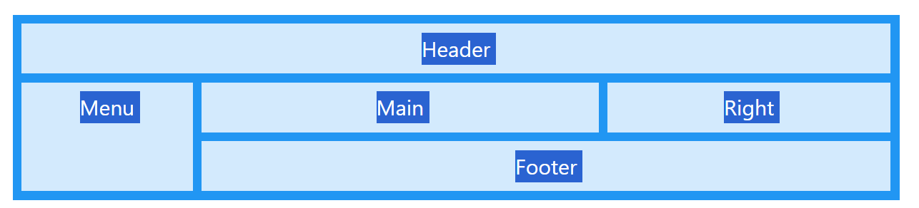
Grid Layout
The CSS Grid Layout Module offers a grid-based layout system, with rows and columns, making it easier to design web pages without having to use floats and positioning.

Grid Elements
A grid layout consists of a parent element, with one or more child elements.
Example
<div class="grid-container">
<div class="grid-item">1</div>
<div class="grid-item">2</div>
<div class="grid-item">3</div>
<div class="grid-item">4</div>
<div class="grid-item">5</div>
<div class="grid-item">6</div>
<div class="grid-item">7</div>
<div class="grid-item">8</div>
<div class="grid-item">9</div>
</div>
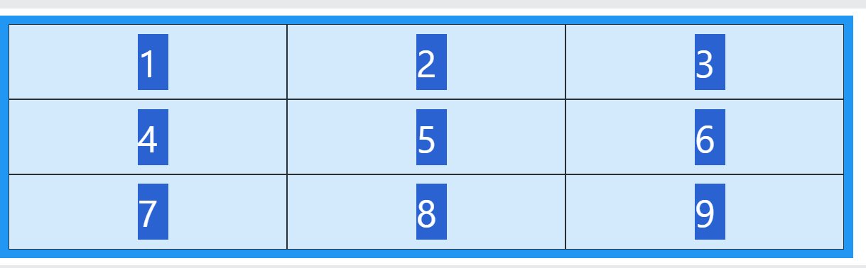

Display Property
An HTML element becomes a grid container when its display property is set to grid or inline-grid.
Example
.grid-container {
display: grid;
}
Example
.grid-container {
display: inline-grid;
}
All direct children of the grid container automatically become grid items.

Grid Columns
The vertical lines of grid items are called columns.
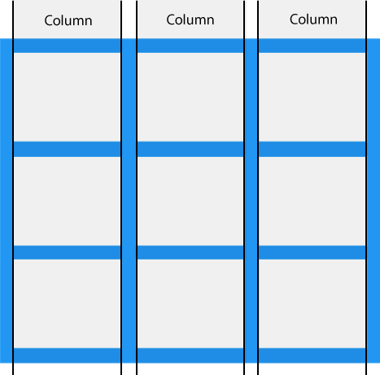

Grid Rows
The horizontal lines of grid items are called rows.
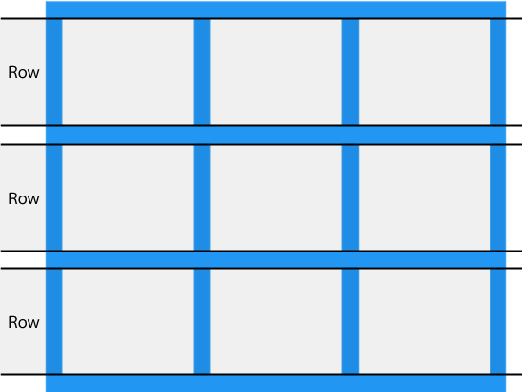

Grid Gaps
The spaces between each column/row are called gaps.
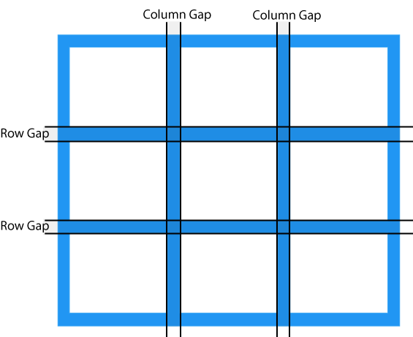
You can adjust the gap size by using one of the following properties:
- column-gap
- row-gap
- gap
Example
The column-gap property sets the gap between the columns:
.grid-container {
display: grid;
column-gap: 50px;
}
Example
The row-gap property sets the gap between the rows:
.grid-container {
display: grid;
row-gap: 50px;
}
Example
The gap property is a shorthand property for the row-gap and the column-gap properties:
.grid-container {
display: grid;
gap: 50px 100px;
}
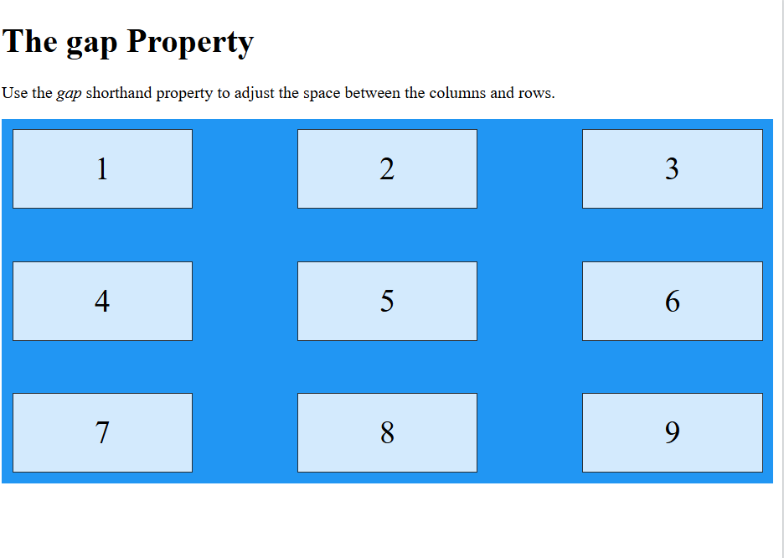
<!DOCTYPE html>
<html>
<head>
<style>
.grid-container {
display: grid;
gap: 50px 100px;
grid-template-columns: auto auto auto;
background-color: #2196F3;
padding: 10px;
}

.grid-item {
background-color: rgba(255, 255, 255, 0.8);
border: 1px solid rgba(0, 0, 0, 0.8);
padding: 20px;
font-size: 30px;
text-align: center;
}
</style>
</head>
<body>

<h1>The gap Property</h1>

<p>Use the <em>gap</em> shorthand property to adjust the space between the columns and rows.</p>

<div class="grid-container">
<div class="grid-item">1</div>
<div class="grid-item">2</div>
<div class="grid-item">3</div>
<div class="grid-item">4</div>
<div class="grid-item">5</div>
<div class="grid-item">6</div>
<div class="grid-item">7</div>
<div class="grid-item">8</div>
<div class="grid-item">9</div>
</div>

</body>
</html>

Example
The gap property can also be used to set both the row gap and the column gap in one value:
.grid-container {
display: grid;
gap: 50px;
}
Grid Lines
The lines between columns are called column lines.
The lines between rows are called row lines.
Property | Description
column-gap | Specifies the gap between the columns
gap | A shorthand property for the row-gap and the column-gap properties
grid | A shorthand property for the grid-template-rows, grid-template-columns, grid-template-areas, grid-auto-rows, grid-auto-columns, and the grid-auto-flow properties
grid-area | Either specifies a name for the grid item, or this property is a shorthand property for the grid-row-start, grid-column-start, grid-row-end, and grid-column-end properties
grid-auto-columns | Specifies a default column size
grid-auto-flow | Specifies how auto-placed items are inserted in the grid
grid-auto-rows | Specifies a default row size
grid-column | A shorthand property for the grid-column-start and the grid-column-end properties
grid-column-end | Specifies where to end the grid item
grid-column-gap | Specifies the size of the gap between columns
grid-column-start | Specifies where to start the grid item
grid-gap | A shorthand property for the grid-row-gap and grid-column-gap properties
grid-row | A shorthand property for the grid-row-start and the grid-row-end properties
grid-row-end | Specifies where to end the grid item
grid-row-gap | Specifies the size of the gap between rows
grid-row-start | Specifies where to start the grid item
grid-template | A shorthand property for the grid-template-rows, grid-template-columns and grid-areas properties
grid-template-areas | Specifies how to display columns and rows, using named grid items
grid-template-columns | Specifies the size of the columns, and how many columns in a grid layout
grid-template-rows | Specifies the size of the rows in a grid layout
row-gap | Specifies the gap between the grid rows
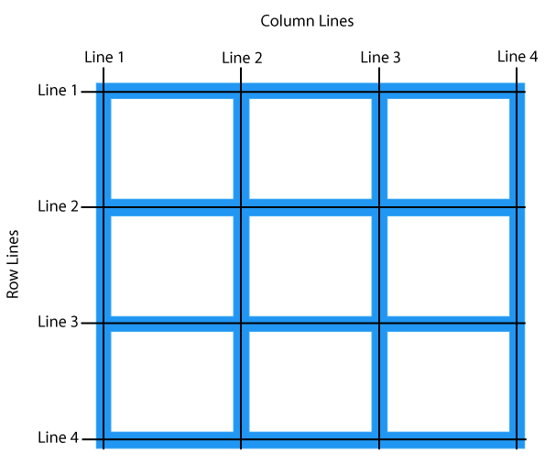
Refer to line numbers when placing a grid item in a grid container:
Example
Place a grid item at column line 1, and let it end on column line 3:
.item1 {
grid-column-start: 1;
grid-column-end: 3;
}
Example
Place a grid item at row line 1, and let it end on row line 3:
.item1 {
grid-row-start: 1;
grid-row-end: 3;
}

All CSS Grid Properties

